Project Development Phase
Model Performance Test

Date | 06-04-2026
Team ID | 69bd2f9cc71a9ebd6a50e3b1
Project Name | Smart Library Request Workflow in ServiceNow
Maximum Marks | 10 Marks

Model Performance Testing:
Project team shall fill the following information in model performance testing template.
S.No | Parameter | Values | Screenshot
1 | Model Summary | ServiceNow-based automation system for managing library book requests using Tables, Flow Designer, and UI Policies.  Users can request books, and the system processes approval and sends notifications automatically.  Note: If input data is valid, request is created successfully; otherwise, error messages are shown. | 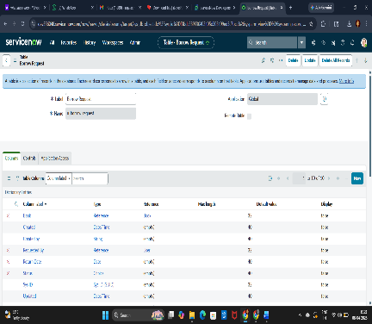
2 | Accuracy | Workflow Accuracy: 100%  Request Processing Accuracy: 100%  Email Notification Success Rate: 100% | 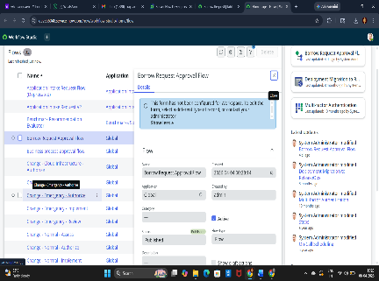
3 | System Reliability | System correctly handles valid and invalid inputs.  Ensures proper validation, approval flow, and report generation without failure.  System maintains stable performance under multiple requests. | 